# Build instructions for 4MHz clock generator for CAN4DC v8

## Introduction

These are build instructions for the 4MHz clock generator circuit used to synchronise CAN4DC modules.

Static Precautions are vital when handling the major Integrated Circuits, such as the 4069UCB and MAX3485CPA which should be left in their protective bag or tube until instructed to install.

These supplemental instructions construct a clock generator circuit on stripboard.

Only a single clock generator is required for multiple CAN4DC modules.

## System diagram

CAN4DC uses a 4MHz twisted pair bus for synchronisation. This bus must be terminated with 120ohm resistors at each end. A single clock generator circuit is used to drive the bus.

120 ohm termination resistor

Twisted pair CBUS bus

120 ohm termination resistor

…

CAN4DC V8

CAN4DC V6

Clock receiver

Clock generator

Twisted pair synchronisation clock bus

120 ohm termination resistor

120 ohm termination resistor

## Tools Required

* Soldering iron
* Solder
* 3mm flat bladed screwdriver
* Side cutters
* Volt meter
* 5V / 12V Power supply
* Knife

## Circuit Diagram

The circuit diagram for the clock generator is shown below.

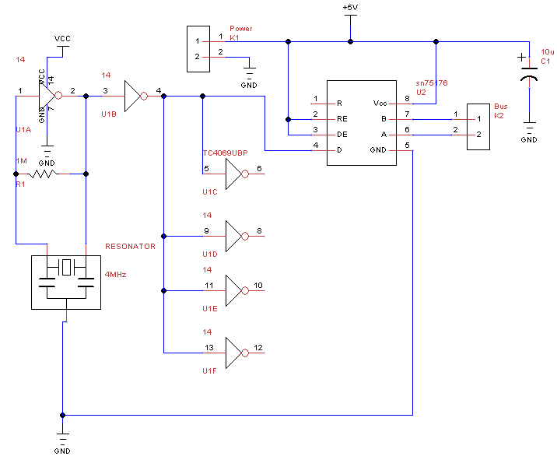

## Stripboard

The circuit is built on a piece of stripboard of size 14 strips by 27 holes.

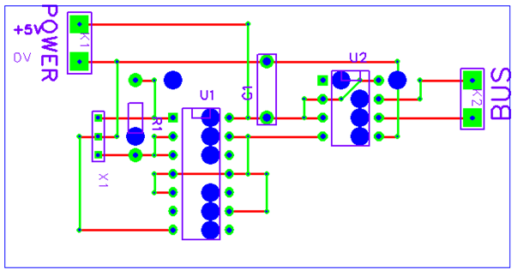

## Parts List

|  |  |  |  |
| --- | --- | --- | --- |
| **Reference** | **Quantity** | **Value** | **Notes** |
|  | 1 | Stripboard 14 strips by 27 holes |  |
| C1 | 1 | 47uF electrolytic 6V |  |
| U1 | 1 | TC4069UBP |  |
|  | 1 | 14 pin DIL socket |  |
| U2 | 1 | SN75176 |  |
|  | 1 | 8 pin DIL socket |  |
| K1, K2 | 2 | Connector 2 pole 0.2” pitch |  |
| R1 | 1 | 1M ohm 0.25W resistor |  |
| C1 | 1 | 10uF electrolytic capacitor |  |
| X1 | 1 | 4MHz Ceramic resonator |  |

In addition some single core wire for making links is required.

## Build steps

1. Cut the copper strips at the thirteen points shown by large blue circles.
2. Fit the twelve wire links shown in green.
3. Fit C1 electrolytic capacitor. Ensure the lead next to the 0 on the can goes towards the top of the board.
4. Fit the two connectors.
5. Fit the U1 14pin DIL IC socket. Ensure the notch of the socket is at the top of the board.
6. Fit the U2 8pin DIL IC socket. Ensure the notch of the socket is at the top of the board.
7. Fit the R1 resistor.
8. Fit the X1 ceramic resonator.
9. **Take anti static precautions** and insert the integrated circuits into their sockets.

## Physical mounting

1. Drill 4mm holes at the top right and bottom left corners of the stripboard.
2. Remove copper strips near the mounting holes to prevent short circuits.

## Connection

1. Connect +5V to top connection of the power connector.
2. Connect 0V to the bottom connection of the power connector.
3. Connect the clock bus to the bus connector observing the A and B polarity.

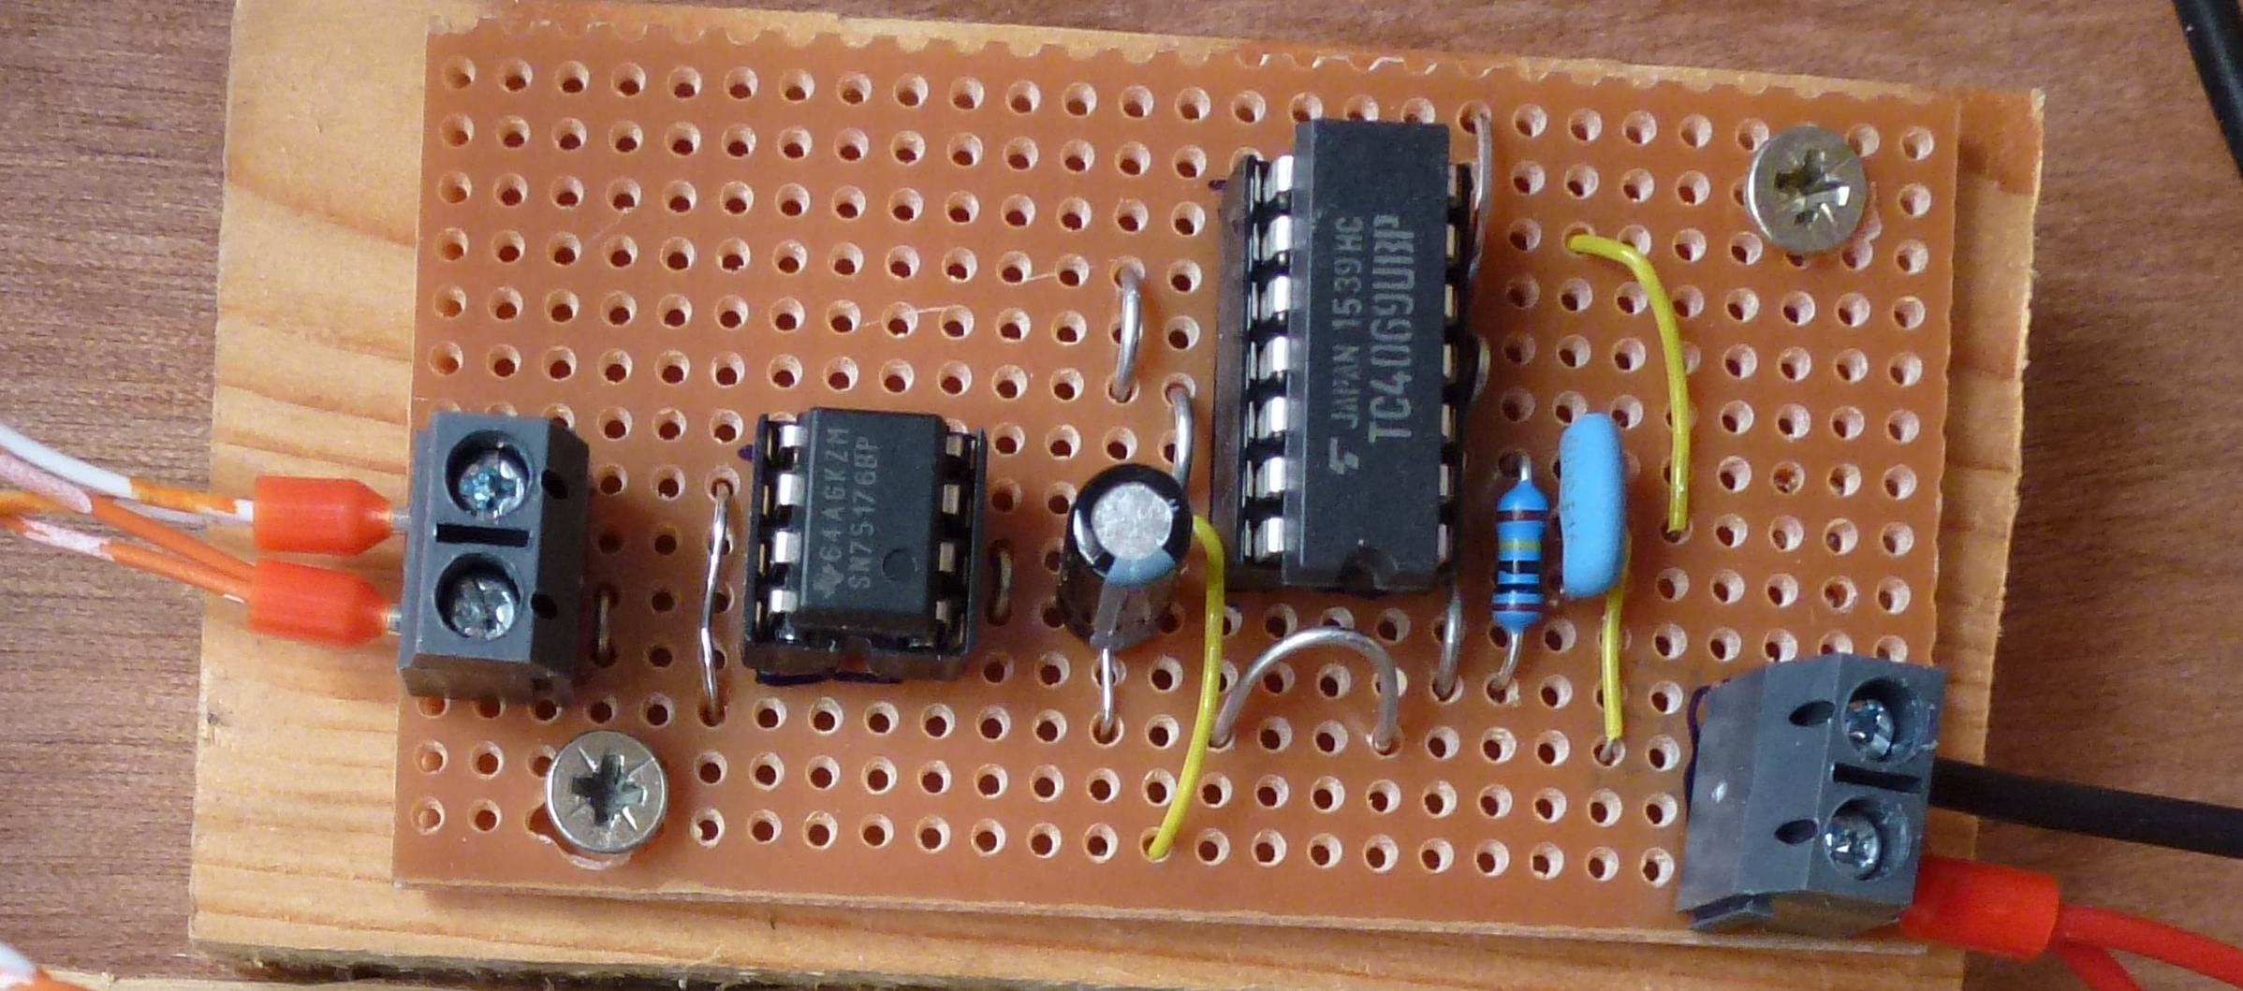

Note that in this photo an additional wire loop has been fitted into the 0V track above the TC4069UDP so that connections could be made for testing. This is not normally required.

Build Complete